CDT (Free-drawn)

CDT (Pre-drawn)

CDT (Examiner clock #1)

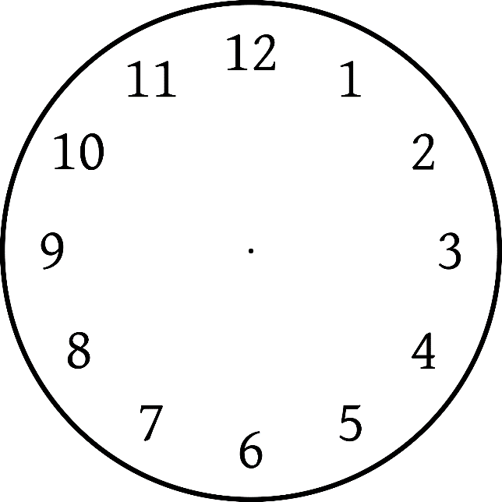

CDT (Examiner clock #2)

CDT (Examiner clock #3)

